**FINAL ASSIGNMENT**

**MILESTONE-1**

**QUERY-1:**

SELECT avg(n.nav) as avg_nav, avg(n.repurchase_price) as avg_repurchase_price, avg(n.sale_price) as avg_sales_price

from "MAIN_ASSIGNMENT"."DBT"."NAVHISTORY" n left join "MAIN_ASSIGNMENT"."DBT"."MUTUALFUND" m on n.code = m.code group by m.category_id, month(n.nav_date);

**OUTPUT:**

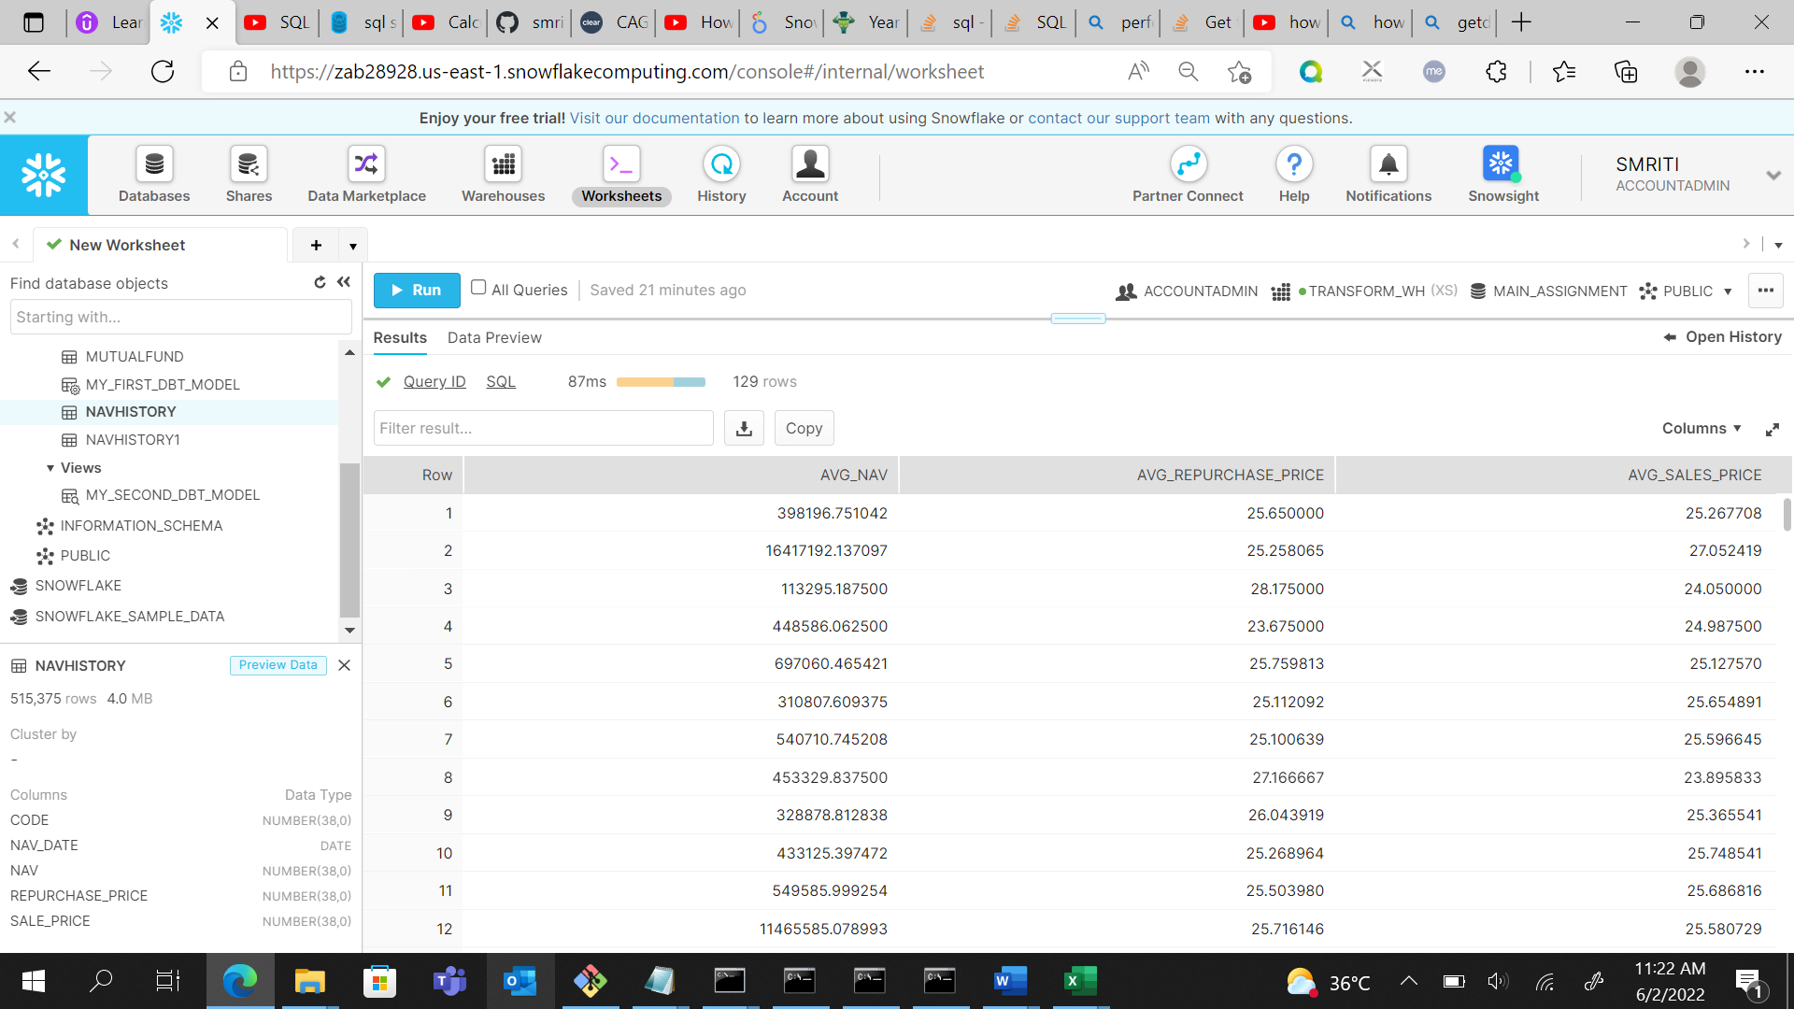

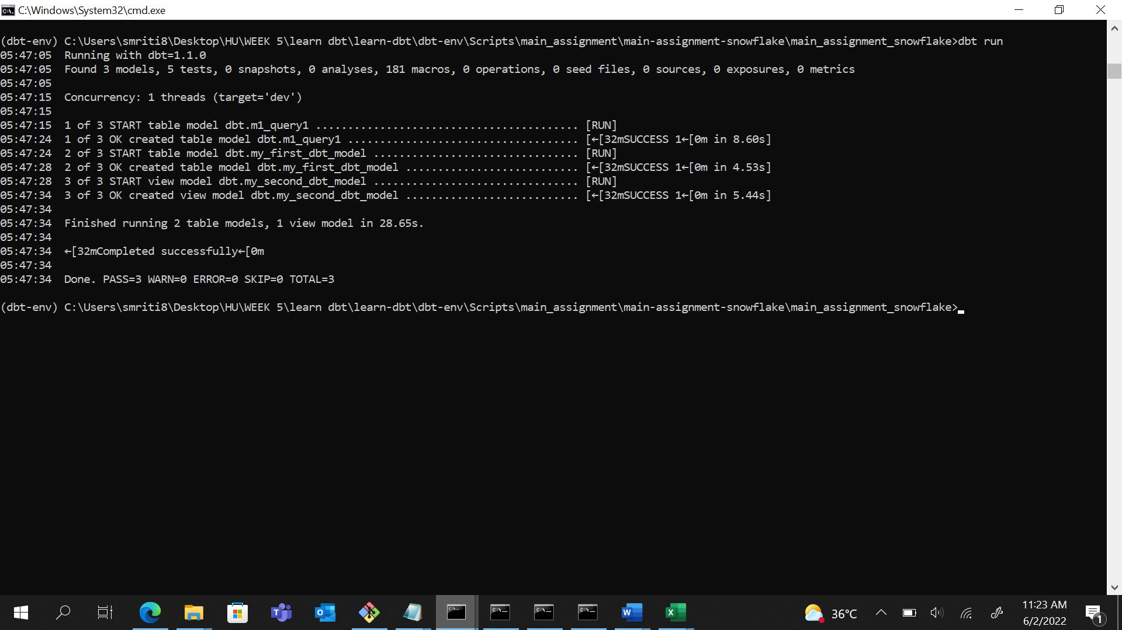

**QUERY-2:**

1. select nav_date as date, nav from "MAIN_ASSIGNMENT"."DBT"."NAVHISTORY" where nav IN (select max(nav) as nav from "MAIN_ASSIGNMENT"."DBT"."NAVHISTORY"

UNION ALL select min(nav) as nav from "MAIN_ASSIGNMENT"."DBT"."NAVHISTORY");

**OUTPUT:**

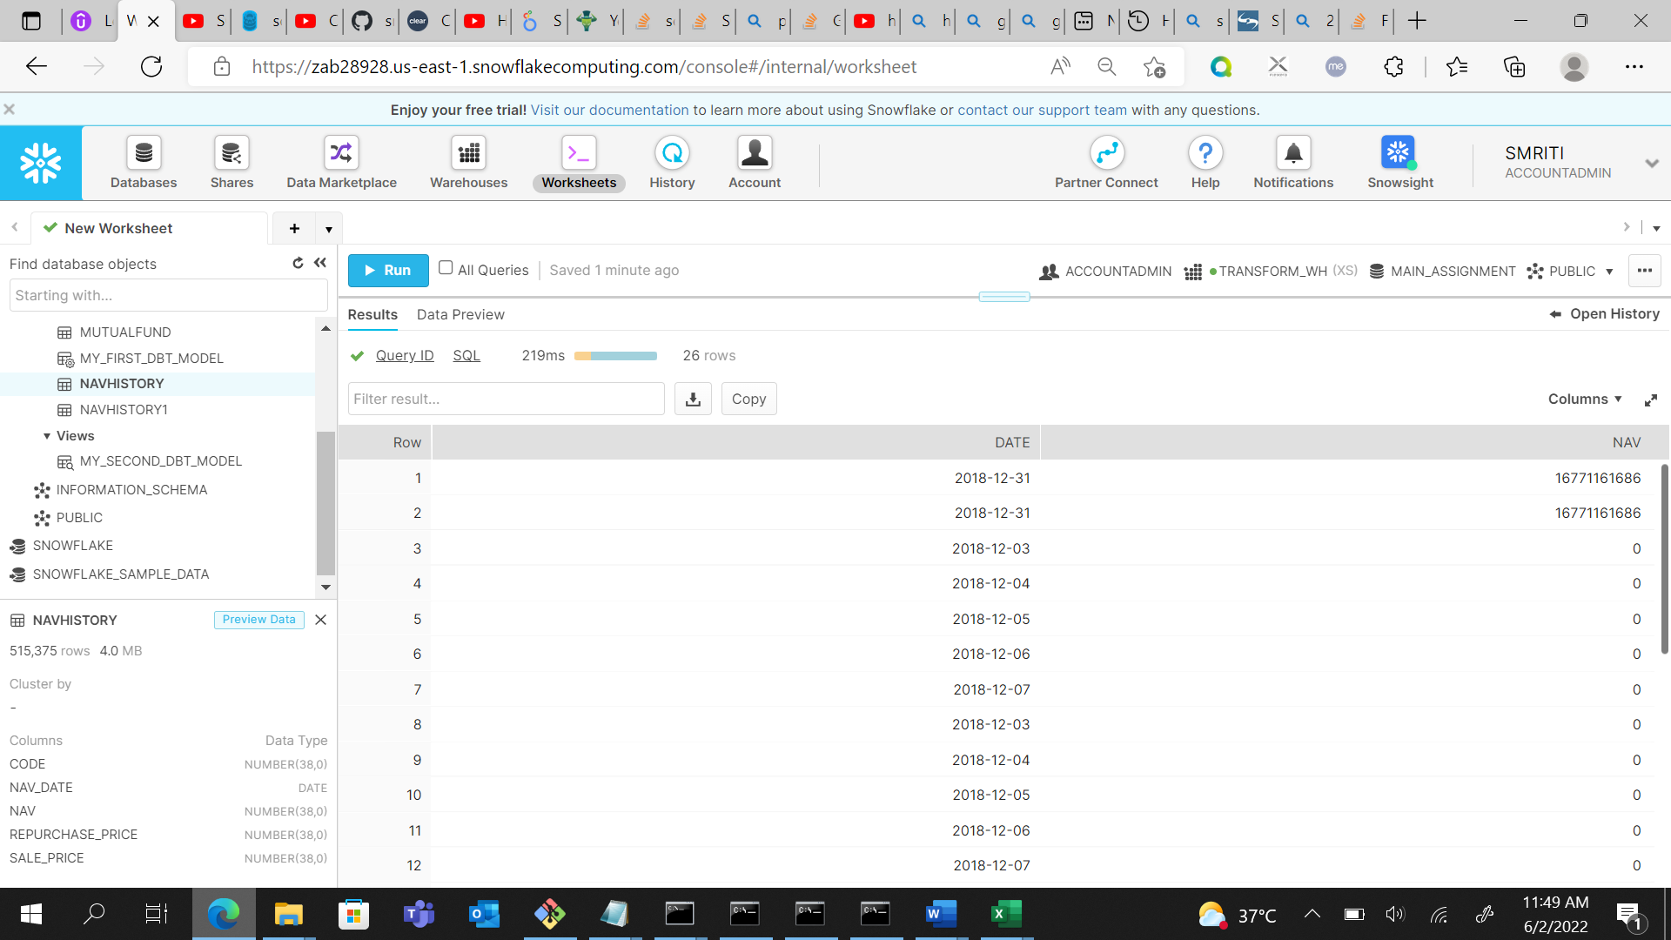

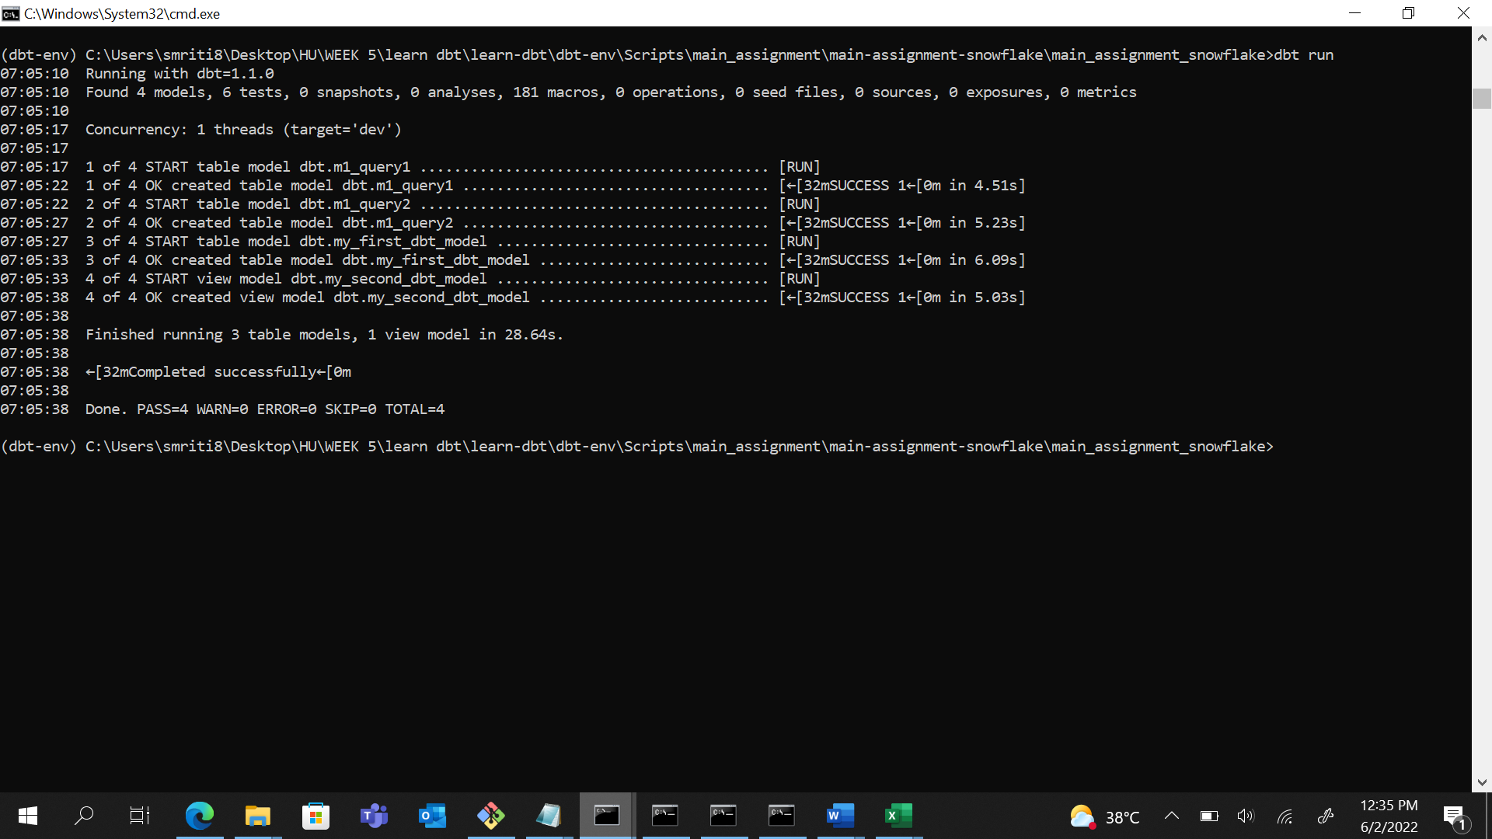

**MILESTONE-2**

**QUERY-1:**

For YTD, MTD:

select code, nav_date, nav, sum(nav) over (partition by year(nav_date), month(nav_date) order by nav_date rows between unbounded preceding and current row) as mtd,

sum(nav) over (partition by year(nav_date) order by nav_date rows between unbounded preceding and current row) as ytd

from "MAIN_ASSIGNMENT"."DBT"."NAVHISTORY";

**OUTPUT:**

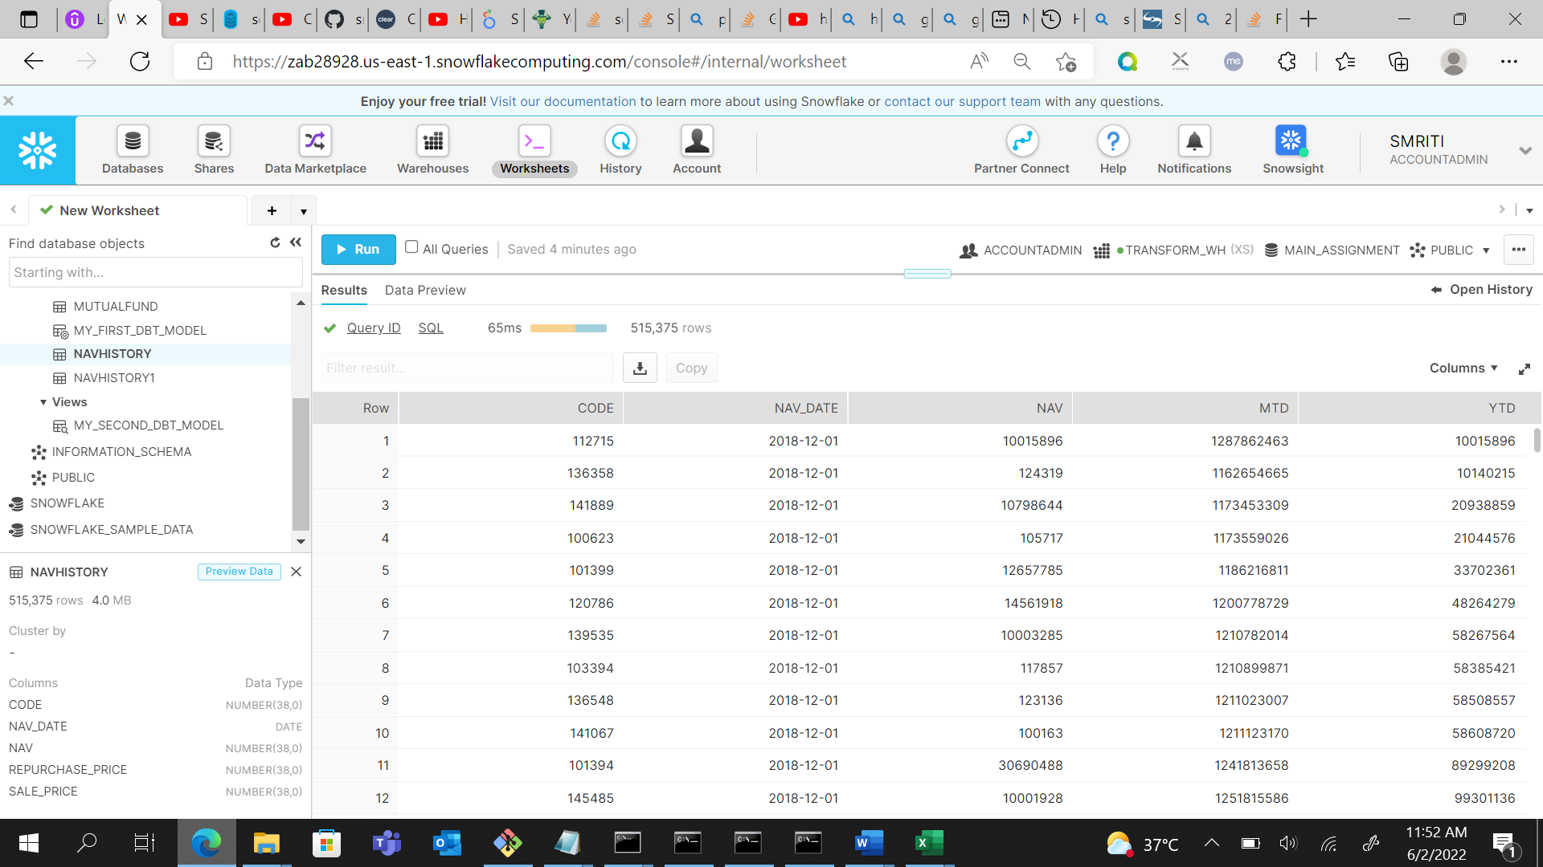

For 1 year

1. select cast(nav_date AS DATE) = cast(DATEADD(year, -1, getdate()) AS DATE) from "MAIN_ASSIGNMENT"."DBT"."NAVHISTORY";
2. select * from "MAIN_ASSIGNMENT"."DBT"."NAVHISTORY"

where nav_date >= (DATEADD(year, -1, getdate()))

and nav_date < DATEADD(Day, 1, (DATEADD(year, -1, getdate())));

**OUTPUT:**

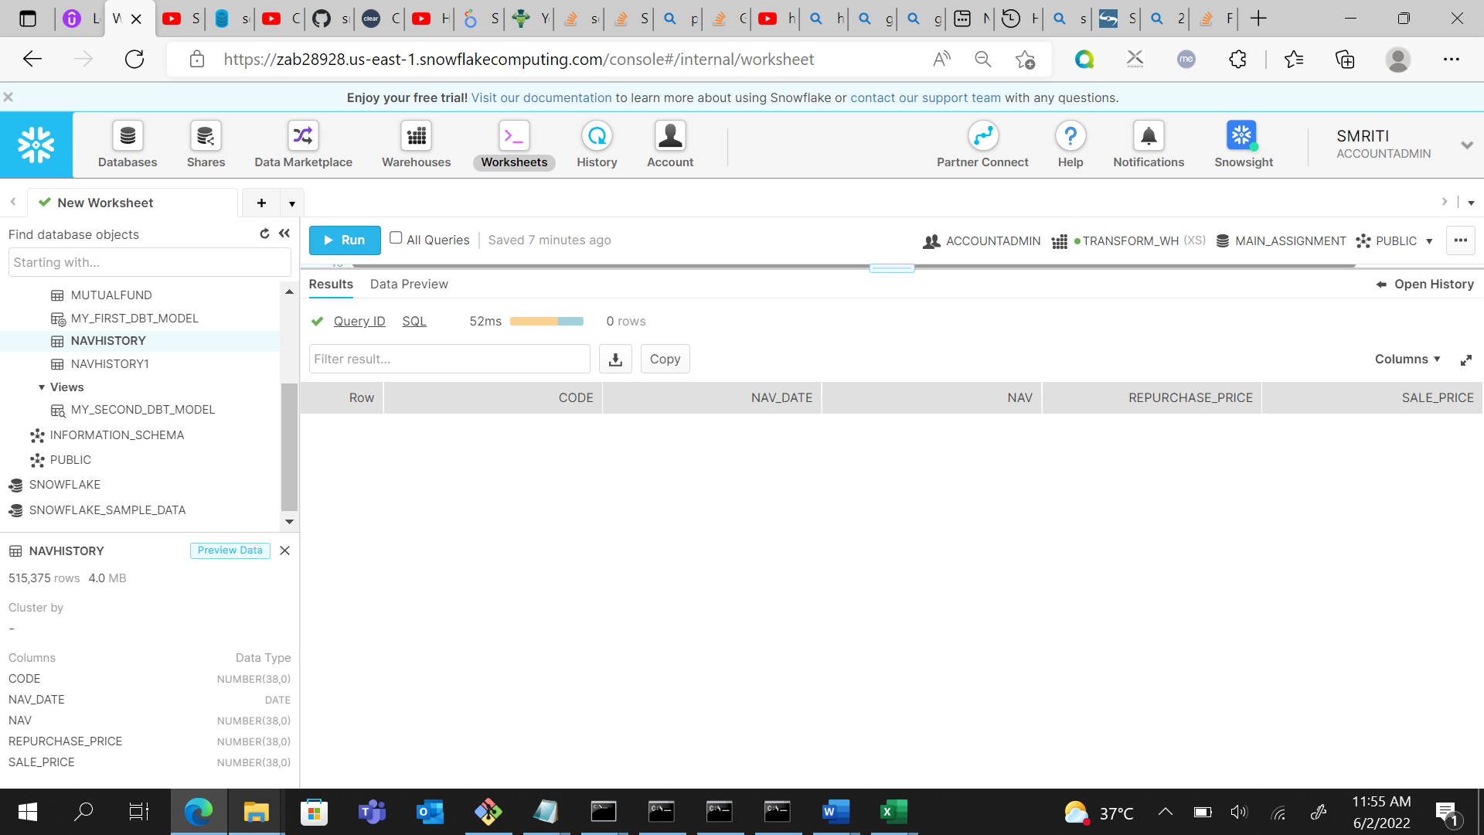

Both, are printing 0 rows as output.

For since inception return, I calculated CAGR.

select *, power((repurchase_price/sale_price), (1/2))*100 as cagr from "MAIN_ASSIGNMENT"."DBT"."NAVHISTORY";

**OUTPUT:**

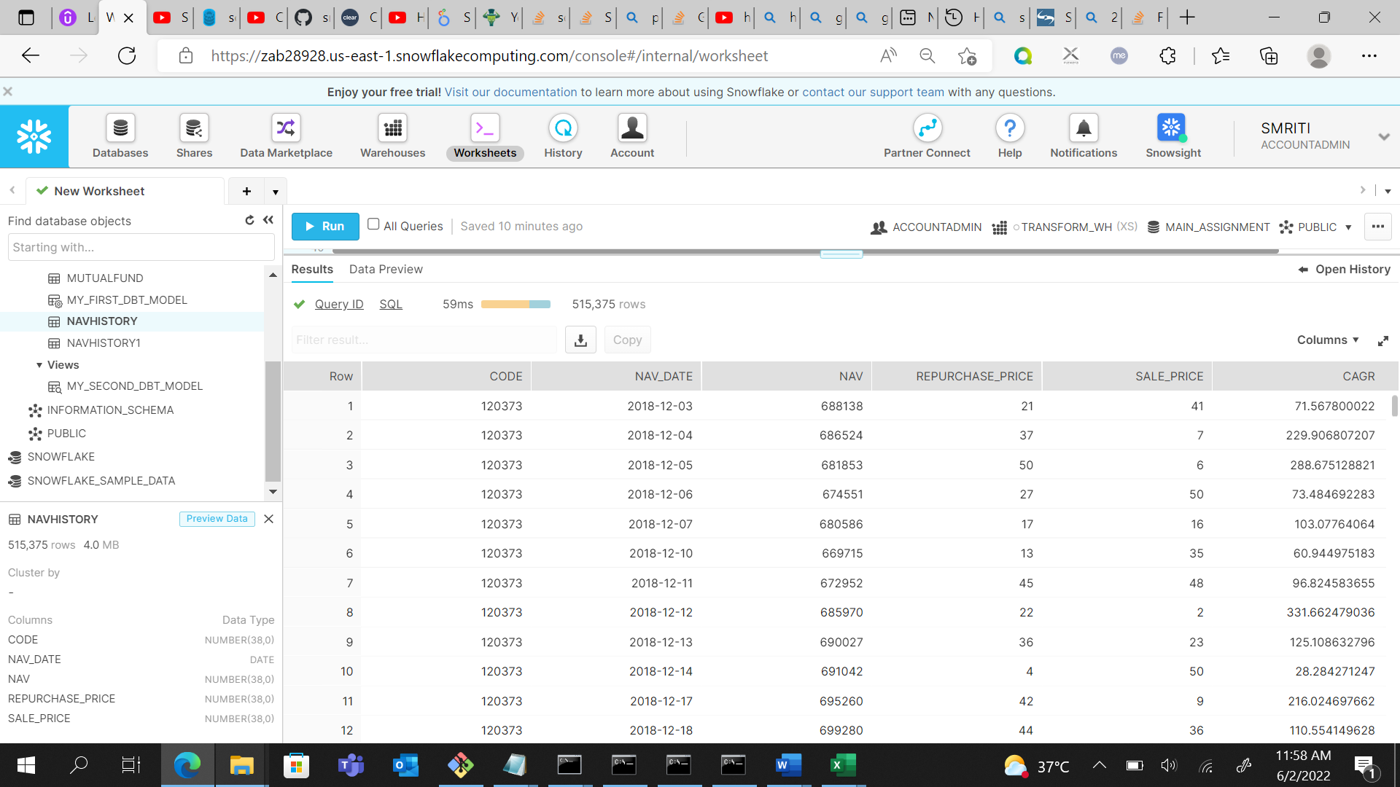

**QUERY-2:**

SELECT *, power((repurchase_price/sale_price), (1/2))*100 as cagr

FROM "MAIN_ASSIGNMENT"."DBT"."NAVHISTORY"

WHERE DATEDIFF(MONTH, nav_date, GETDATE()) <= 3;

**OUTPUT:**

0 rows as output.

**QUERY-3**

select distinct(code), name from "MAIN_ASSIGNMENT"."DBT"."MUTUALFUND" n where not exists

(select * from "MAIN_ASSIGNMENT"."DBT"."NAVHISTORY" m where n.code=m.code);

**OUTPUT:**

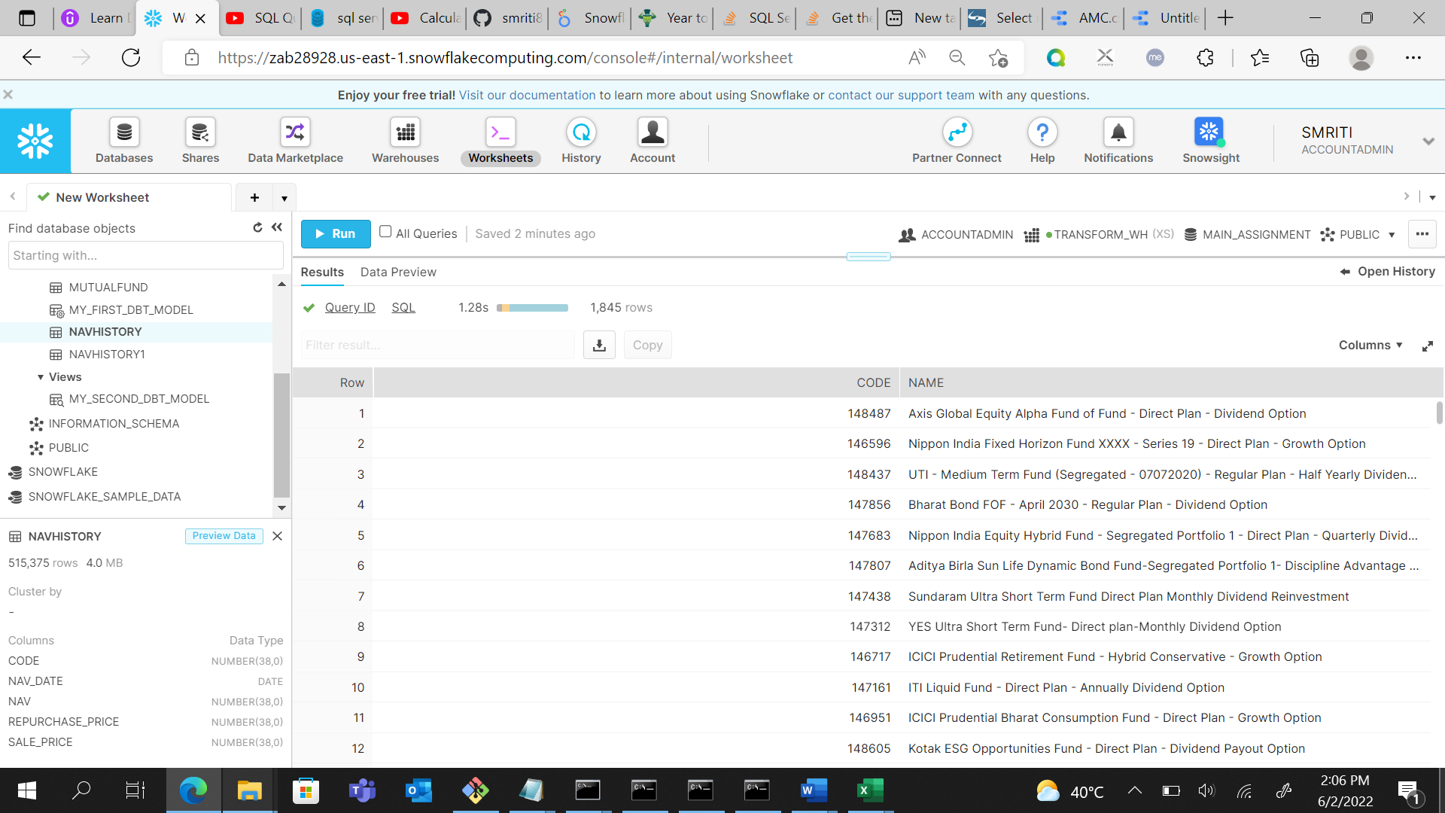

**QUERY-4:**

select n.code, m.category_id, sum(n.nav) over (partition by year(n.nav_date) order by nav_date rows between unbounded preceding and current row) as ytd

, sum(n.nav) over (partition by month(n.nav_date) order by nav_date rows between unbounded preceding and current row) as month

, sum(n.nav) over (partition by week(n.nav_date) order by nav_date rows between unbounded preceding and current row) as weekly

from "MAIN_ASSIGNMENT"."DBT"."NAVHISTORY" n LEFT JOIN "MAIN_ASSIGNMENT"."DBT"."MUTUALFUND" m on n.code = m.code where m.category_id = 2 or m.category_id = 17;

**OUTPUT:**

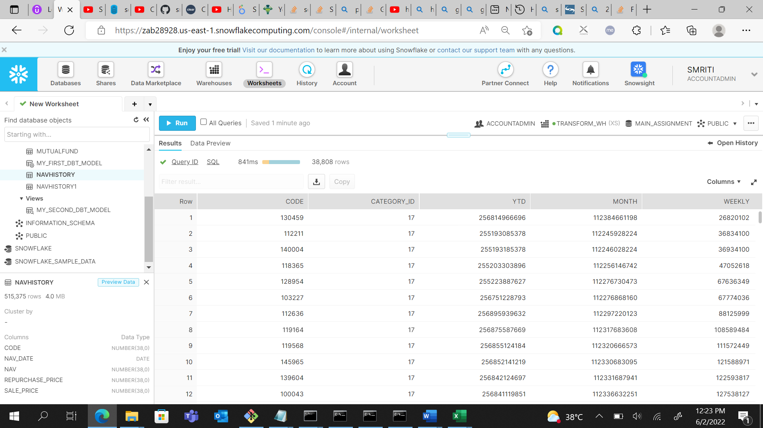

**QUERY-5**

select power((repurchase_price/sale_price), (1/2))*100 as cagr, m.name FROM "MAIN_ASSIGNMENT"."DBT"."NAVHISTORY" n

right join "MAIN_ASSIGNMENT"."DBT"."MUTUALFUND" m on n.code=m.code where name like '%annual%';

**OUTPUT:**